# Educational Organisation using ServiceNow

**Team Id: NM2025TMID14642**

Team Members: 4

Team Leader: Padmamalini.J Team Member 1**:** Boomika Sri.V Team Member 2**:** Gayathiri.M Team Member3: Ananthi.A

**Problem Statement:**

The Educational Management System is a comprehensive platform designed to streamline administrative tasks within educational institutions. It facilitates efficient management of student and teacher data, simplifies the admission process, and provides tools for monitoring student progress.

**Objective:**

**Skills:**

**TASK INITIATION**

**Milestone 1 : Creation Of Update Set Activity 1: Create Local update sets.**

1. Open service now
2. Click on All >> Local update sets.

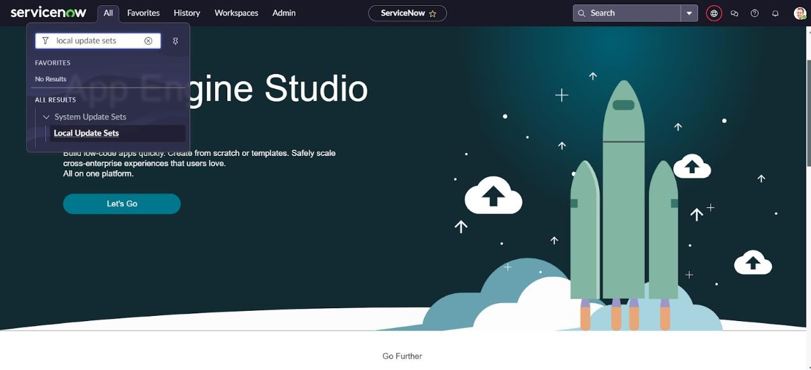

1. Click on new

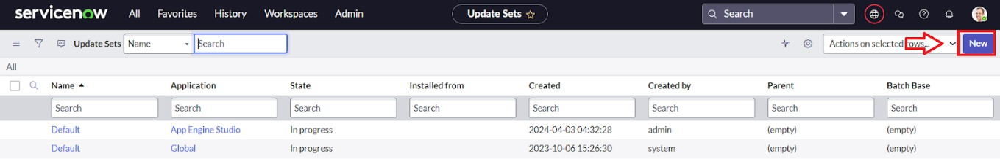

1. Enter the Details Name: Educational Organisation>>Click on Submit and make Current.

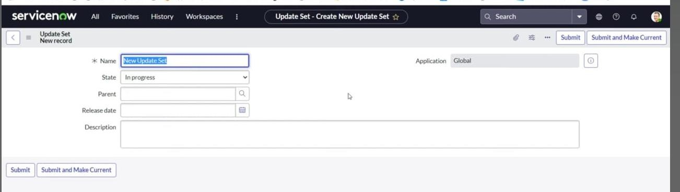

**Milestone 2 : Tables**

**Activity 1: Create Salesforce Table.**

1. Open service now.
2. Click on All >> search for tables

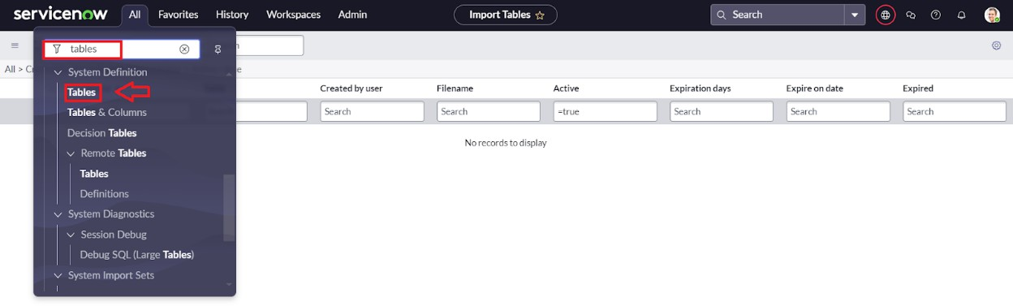

1. Click on new

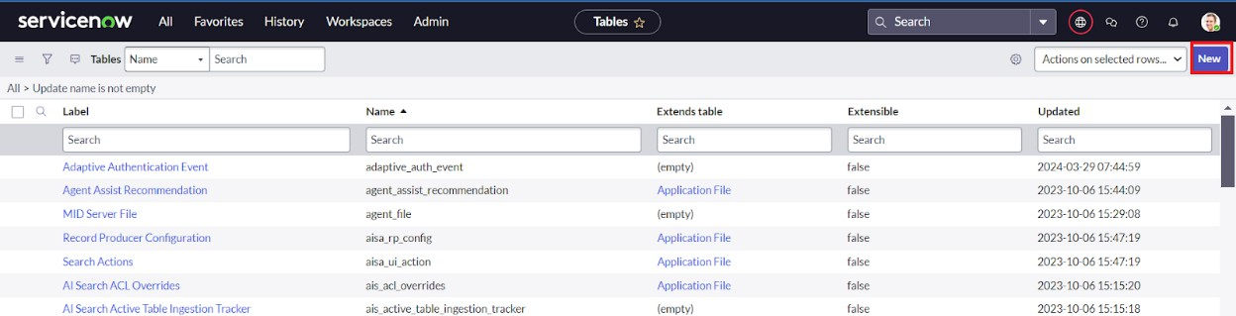

1. Enter the Label(Anything you want): Salesforce >>Click on Name it will Automatically generate Api name.

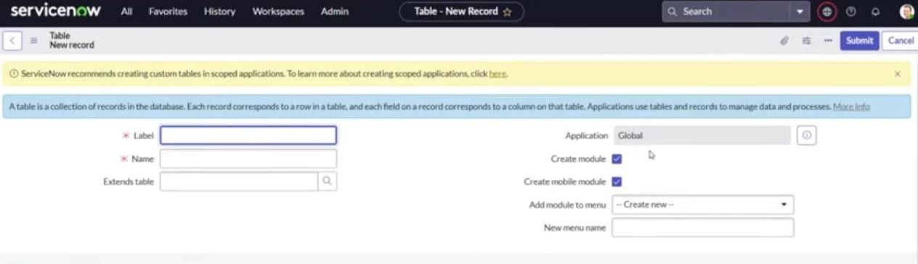

1. Columns as given, Double Click on Column label and Enter the Column labels and click on the tick mark>> Give Type as given.

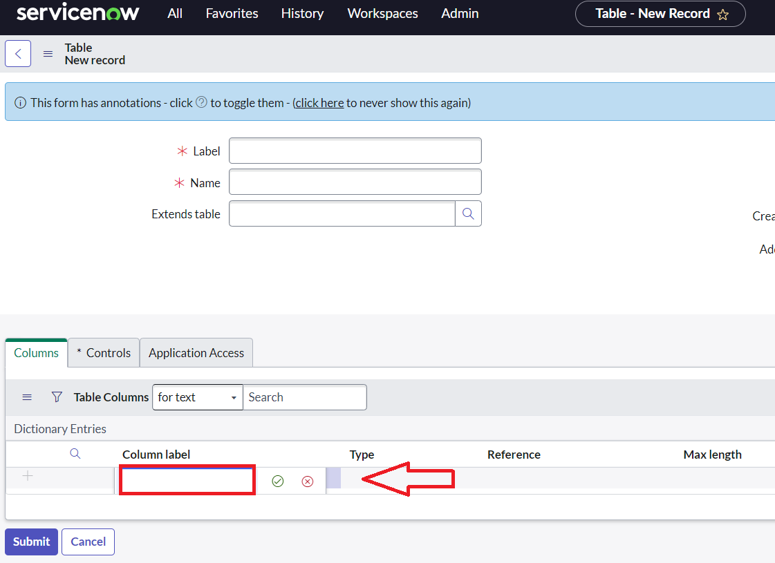

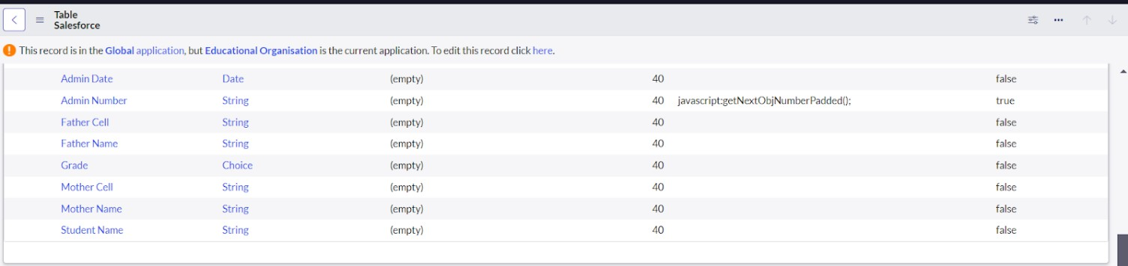

1. For “Admin Number” Give Display as True and right click on the toggle bar on top >> save.

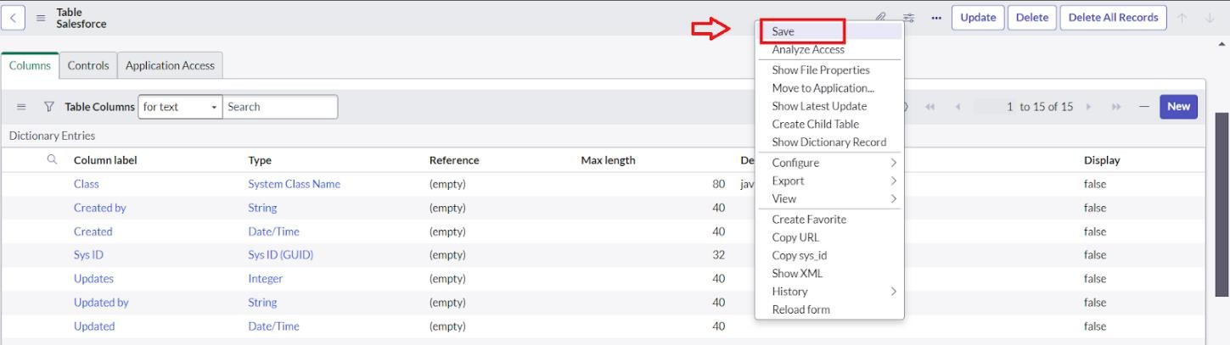

1. Click on controls >> Enable Extensible.

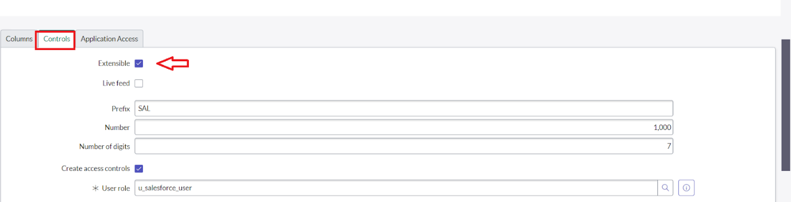

1. Click on “Admin Number” column, In Related Links Click on Advanced View >> Default View (Enable Use dynamic default) >> select Get Next Padded Number in Dynamic default value

>> Update.

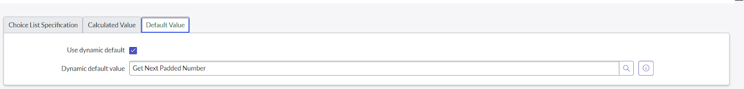

1. Click on “Grade” Column >> Click on Choices and give Label, Value and Sequence as given below.

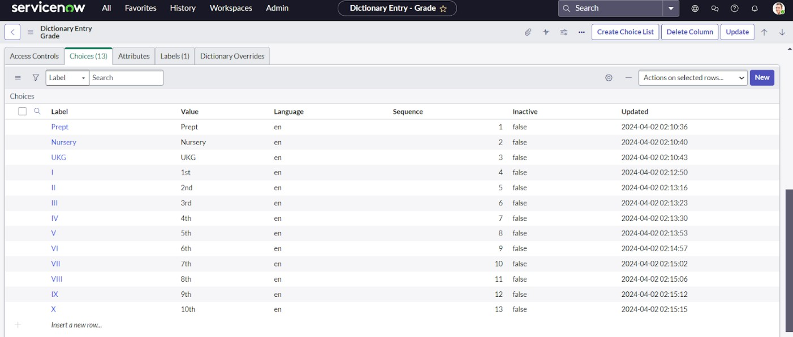

**Activity 1: Create Admission Table**

1. Create an Admission Table with Columns given.
2. Select Extend Tables >> Salesforce and also Select Add module to menu >> Salesforce.
3. Create Fields as shown

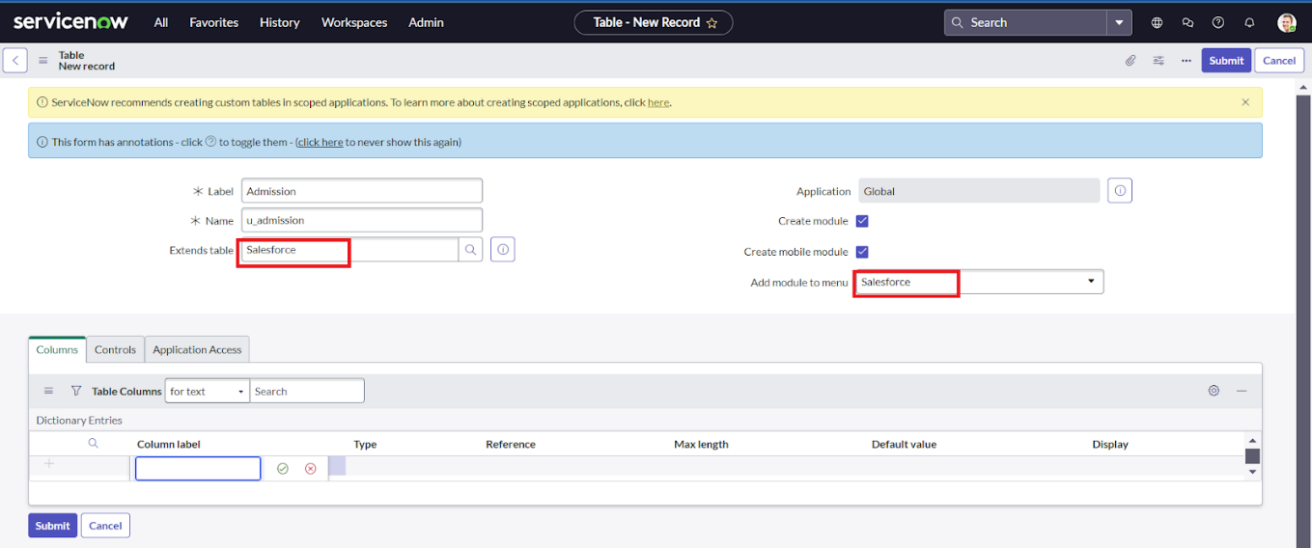

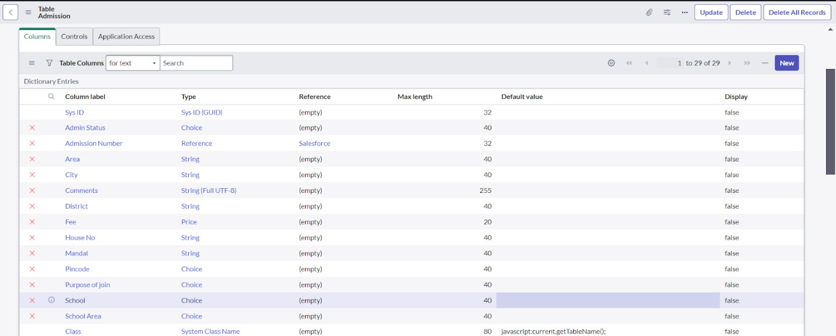

1. 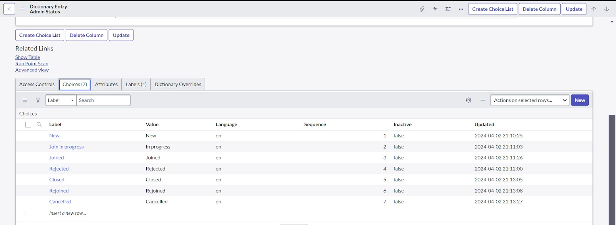Create choice for Admin Status as:
2. Create choice for Pincode as:

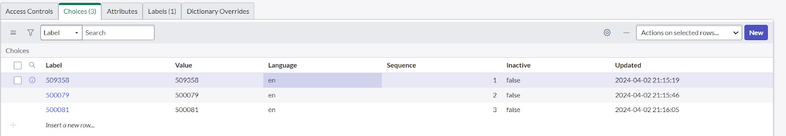

1. Create choice for Purpose of Join as:

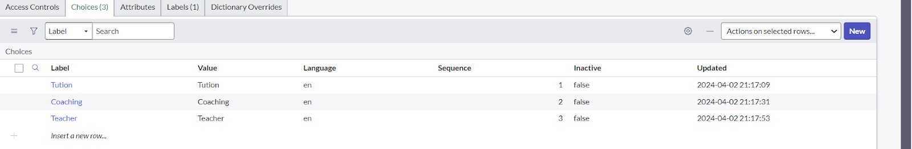

1. Create choice for School as:

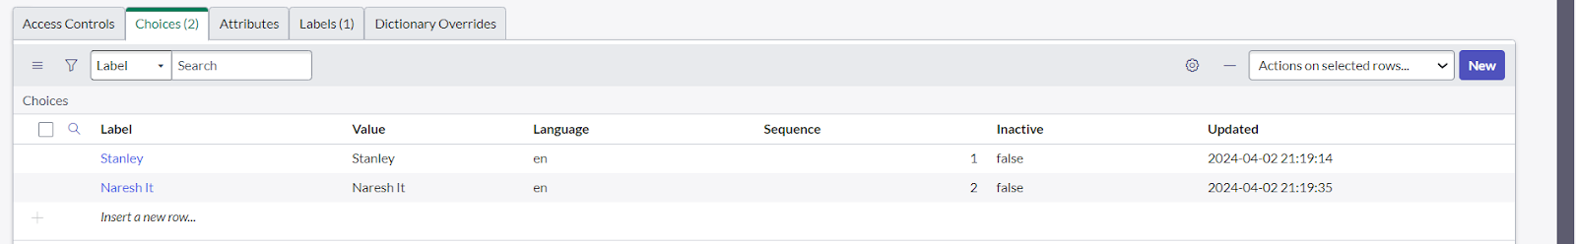

1. Create choice for School area as:

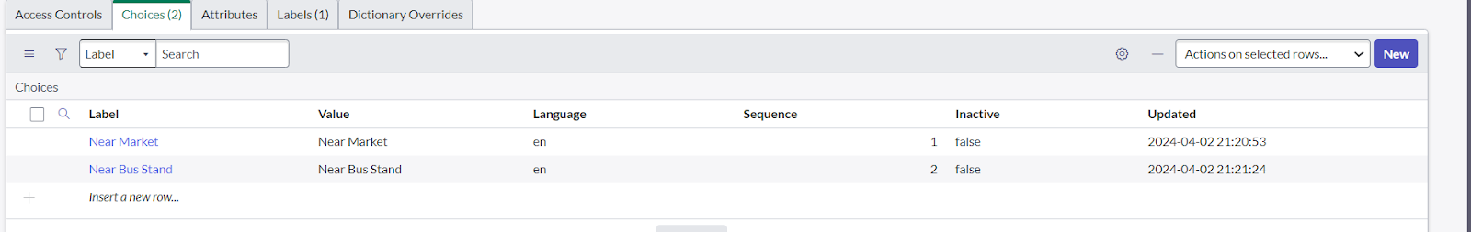

**Activity 3: Create Student Progress Table**

1. Create a Student Progress Table with Columns given.
2. Select Add module to menu >> Salesforce.
3. Create Fields as shown:

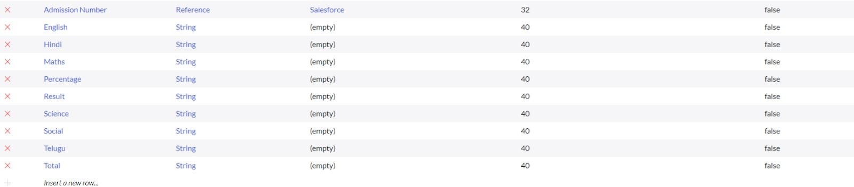

**Milestone 3 : Layout**

**Activity 1: Configure Tables form For Student Progress Table**

1. 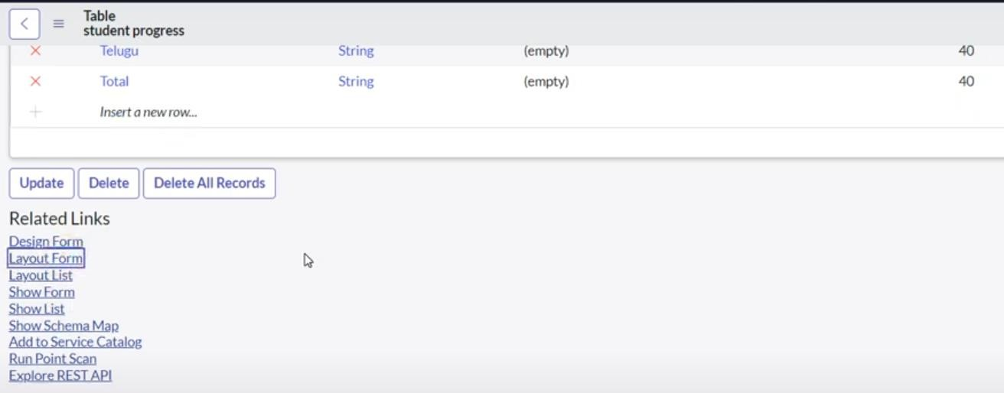In the Student Progress Tabel Page, Click on Layout form.
2. Click on Admission Number[+]

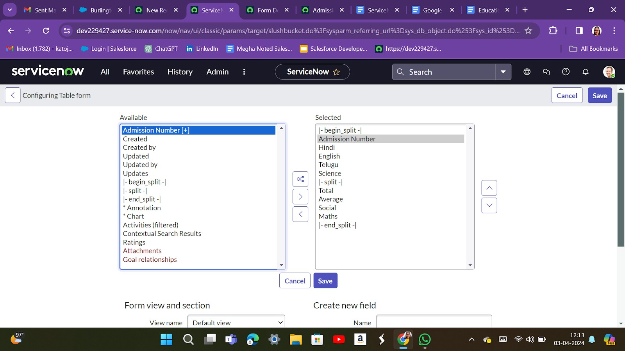

1. 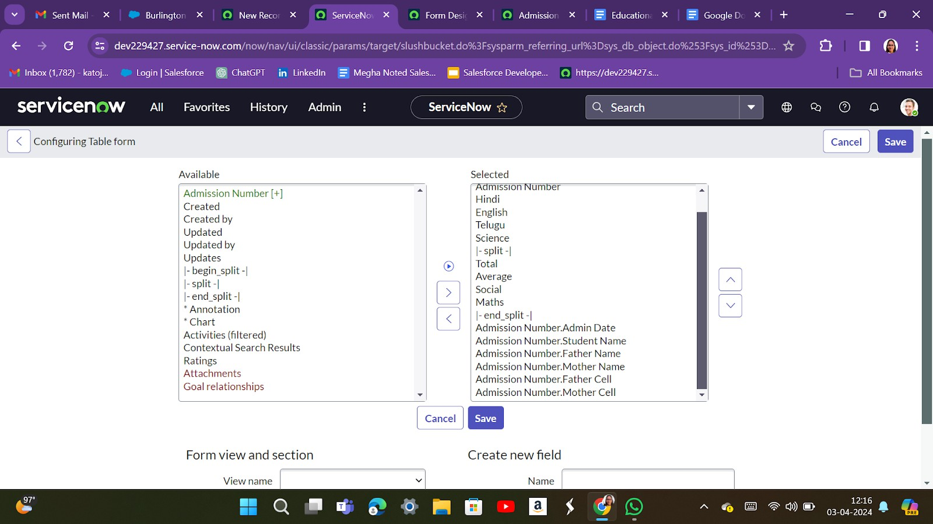Select below Admission Number fields in Available side and send it to selected side as below >> save.

**Milestone 4 : Form Design**

**Activity 1: Creating Form Desing For Salesforce Table**

* 1. Click on All >> System Definition >> Tables
  2. In Label Search for Salesforce and open.

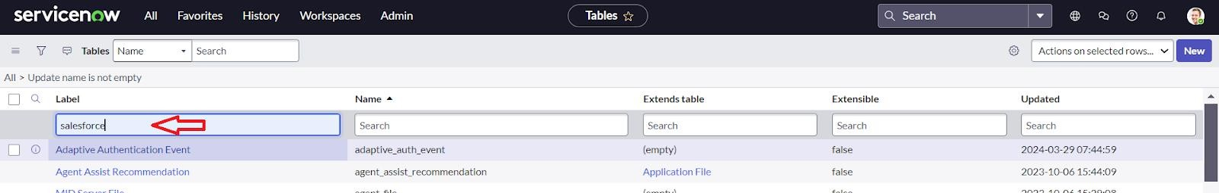

* 1. Right Click on top Toggle >> Configure >> Form Design.

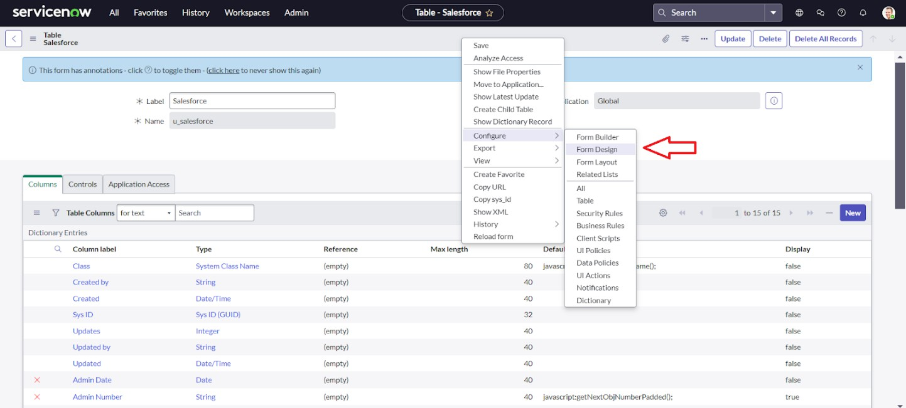

* 1. In drop down select Salesforce(u_salesforce)

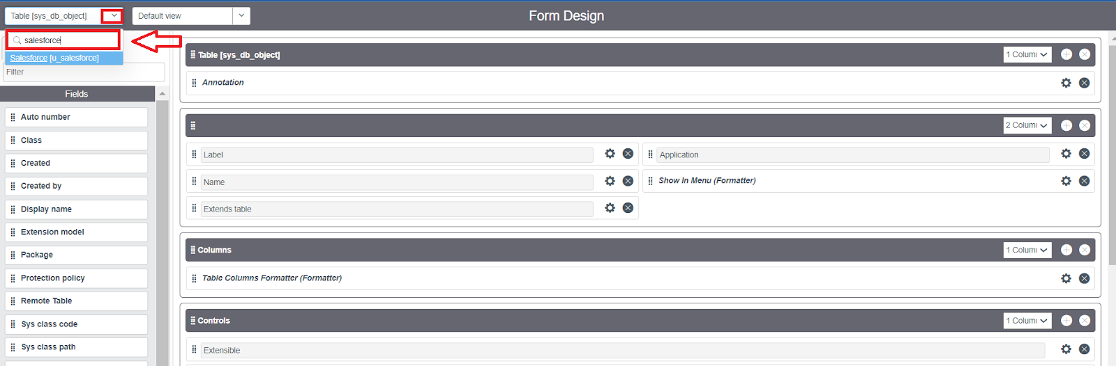

* 1. Drag and drop the fields to the left side as below

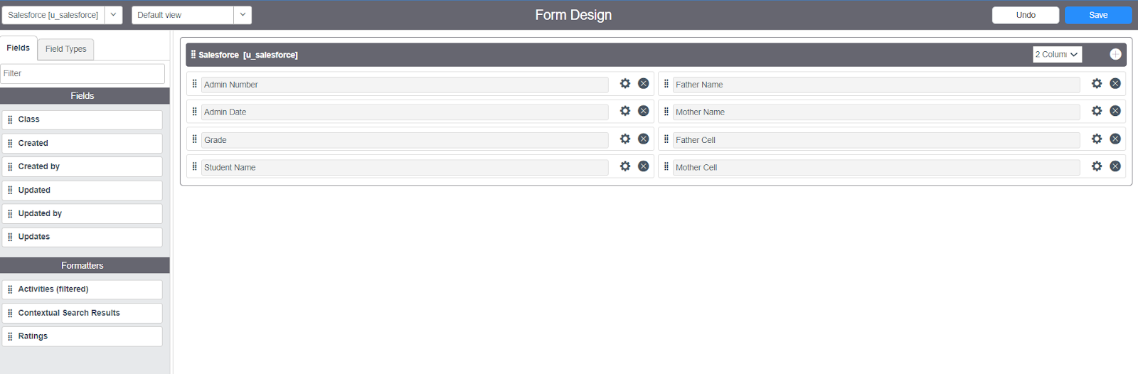

* 1. Save

**Activity 2: Creating Form Design For Admission Table**

1. Follow the same steps as Activity1, Configure the fields as below and Save.

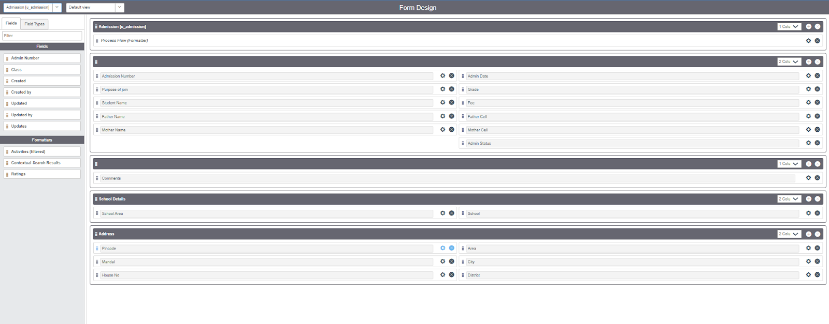

**Activity 3: Creating Form Design For Student Progress Table**

1. Follow the same steps as Activity1, Configure the fields as below and Save.

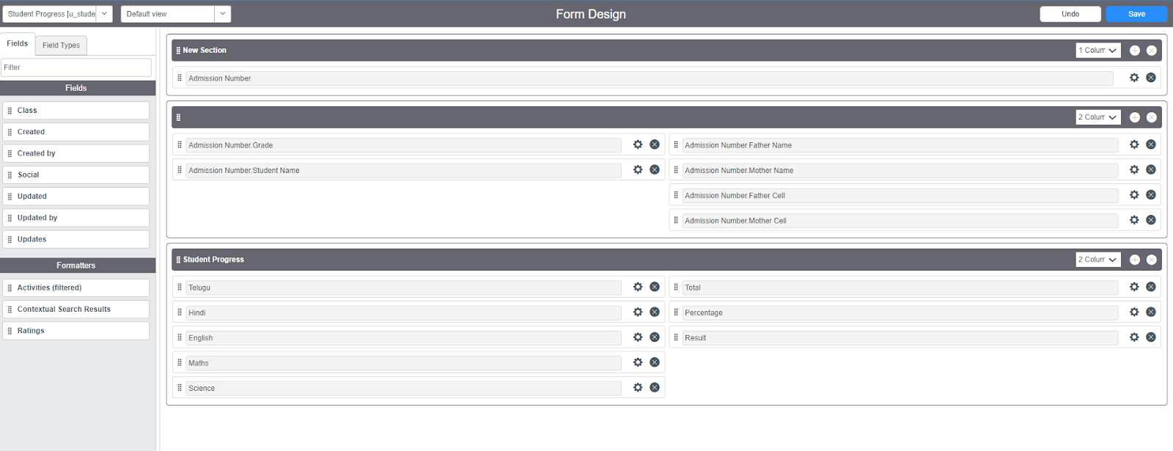

**Milestone 5 : Number Maintenance**

**Activity 1: Creating Number Maintenance For Admin Number**

1. All >> Number Maintenance >> New

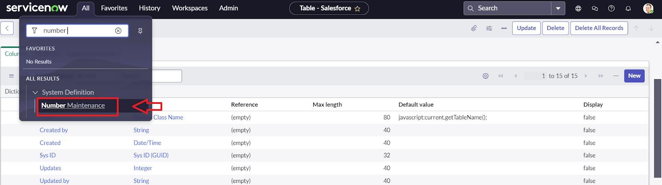

1. Fill the details >> Submit

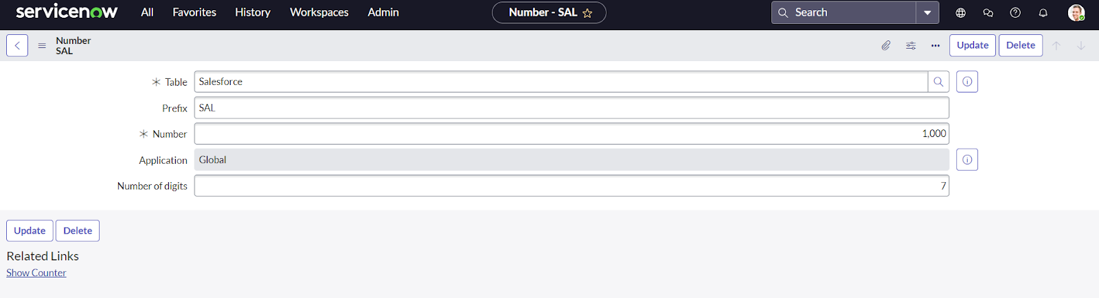

**Milestone 6 : Process**

**Activity 1: Creating Process Flow For Admission Table**

1. All >> Process Flow >> New
2. Fill the Details as given Below

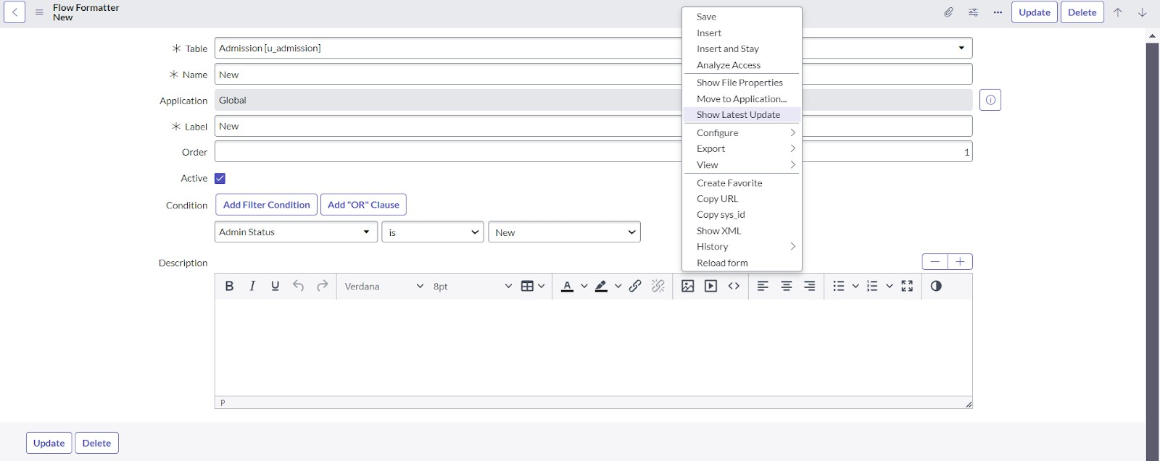

1. Right click on toggle and Click on the save.
2. Replace the Name and Label as below and click on Insert on stay.

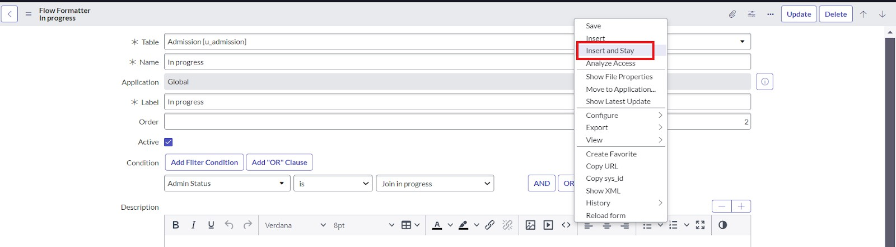

1. Replace the Name and Label in order and click on Insert on stay.

Joined>>Rejected>>Rejoined>>Closed>>Cancelled.

1. Order should be New >> InProgress>>Joined>>Rejected>>Rejoined>>Closed>>Cancelled

# Milestone 7: Client Script

**Activity 1: Creating “Auto Populate” Client Scripts For Admission Table**

1. All >> Client Scripts >> New
2. 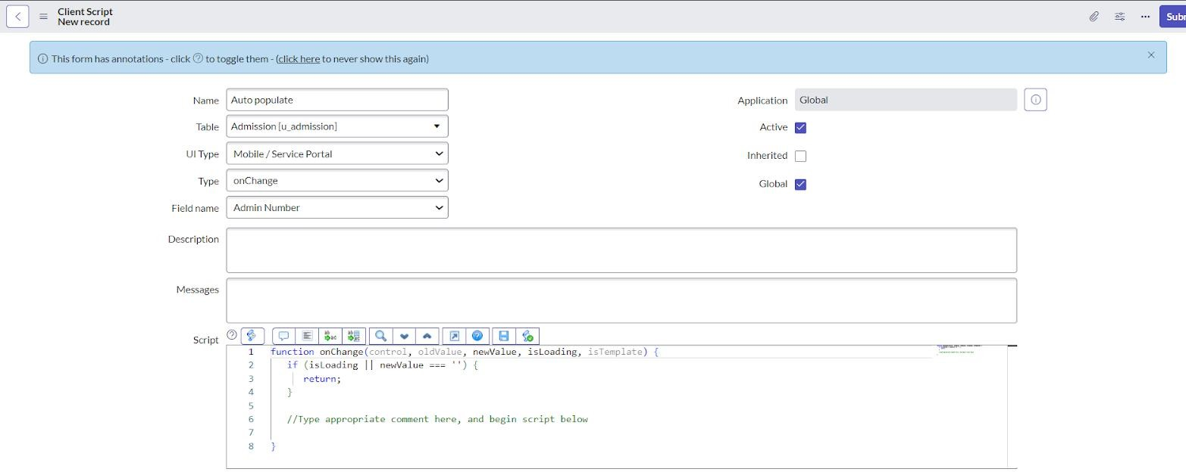Fill the Details as given
3. Write the Code as below, Enable Isolate script and Save. function onChange(control, oldValue, newValue, isLoading, isTemplate) {

if (isLoading || newValue === '') { return;

}

//Type appropriate comment here, and begin script below var a = g_form.getReference('u_admission_number'); g_form.setValue('u_admin_date',a.u_admin_date); g_form.setValue('u_grade',a.u_grade); g_form.setValue('u_student_name',a.u_student_name); g_form.setValue('u_father_name',a.u_father_name); g_form.setValue('u_mother_name',a.u_mother_name); g_form.setValue('u_father_cell',a.u_father_cell); g_form.setValue('u_mother_cell',a.u_mother_cell);

g_form.setDisabled('u_admin_date',a.u_admin_date); g_form.setDisabled('u_grade',a.u_grade); g_form.setDisabled('u_student_name',a.u_student_name); g_form.setDisabled('u_father_name',a.u_father_name); g_form.setDisabled('u_mother_name',a.u_mother_name); g_form.setDisabled('u_father_cell',a.u_father_cell); g_form.setDisabled('u_mother_cell',a.u_mother_cell);}

**Note**: Make sure the Field names should be the same as you created .

**Activity 2: Creating “Pincode Update” Client Scripts For Admission Table**

1. 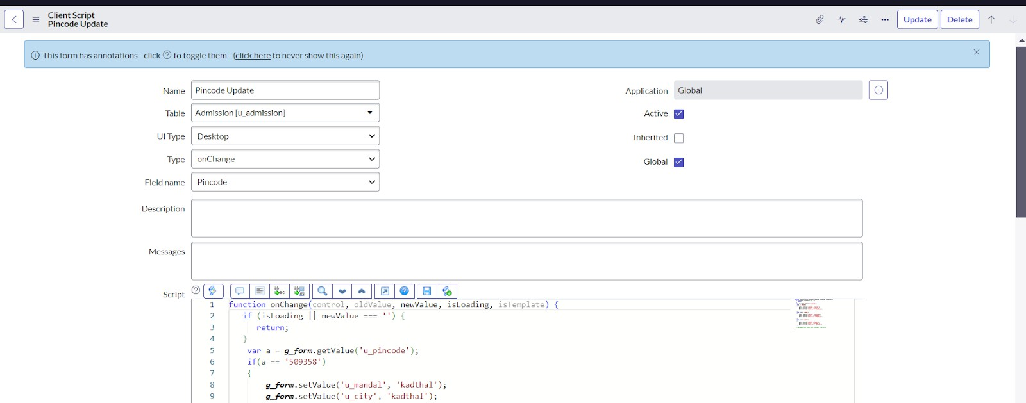Fill the Details as given.
2. Write the Code as below, Enable Isolate script and Save.

function onChange(control, oldValue, newValue, isLoading, isTemplate) { if (isLoading || newValue === '') {

return;

}

var a = g_form.getValue('u_pincode'); if(a == '509358')

{

g_form.setValue('u_mandal', 'kadthal'); g_form.setValue('u_city', 'kadthal'); g_form.setValue('u_district', 'RangaReddy');

}

else if(a == '500081')

{

g_form.setValue('u_mandal', 'karmanghat'); g_form.setValue('u_city', 'karmanghat'); g_form.setValue('u_district', 'RangaReddy');

}

else if(a == '500079')

{

g_form.setValue('u_mandal', 'Abids'); g_form.setValue('u_city', 'AsifNagar'); g_form.setValue('u_district', 'Hyderabad');

}

//Type appropriate comment here, and begin script below

}

**Activity 3: Creating “Disable Fields” Clients Scripts For Students Progress Table**

1. **Fill the Details as given.**

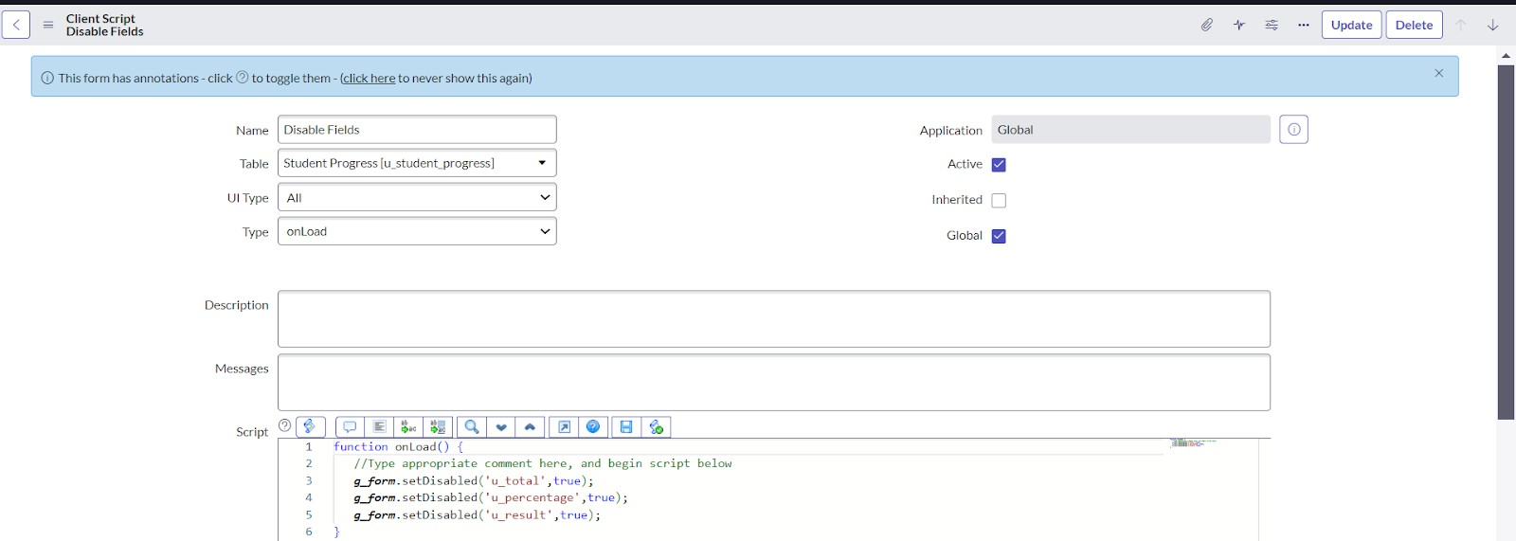

1. Write the Code as below, Enable Isolate script and Save. function onLoad() {

//Type appropriate comment here, and begin script below g_form.setDisabled('u_total',true);

g_form.setDisabled('u_percentage',true); g_form.setDisabled('u_result',true);

}

**Activity 4: Creating “Total Update” Clients Scripts For Student Progress Table**

1. Fill the Details as given.

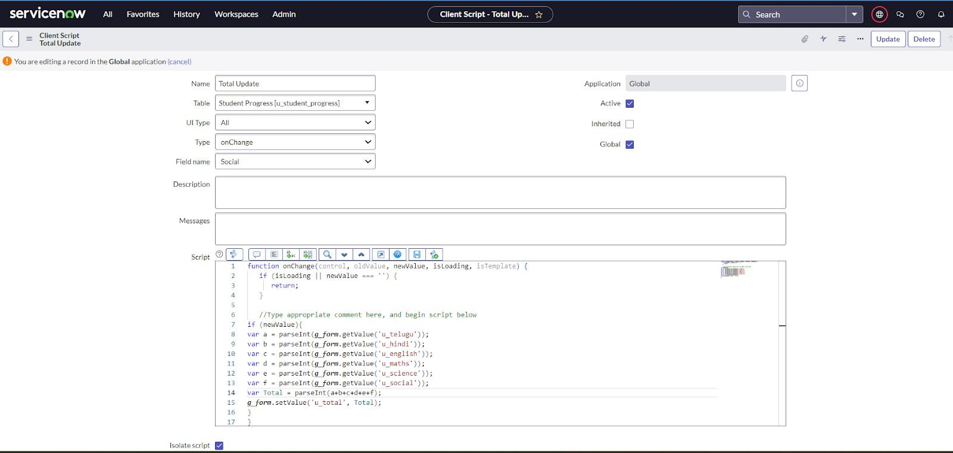

1. Write the Code as below, Enable Isolate script and Save.

function onChange(control, oldValue, newValue, isLoading, isTemplate) { if (isLoading || newValue === '') {

return;

}

//Type appropriate comment here, and begin script below if (newValue){

var a = parseInt(g_form.getValue('u_telugu')); var b = parseInt(g_form.getValue('u_hindi')); var c = parseInt(g_form.getValue('u_english'));

var d = parseInt(g_form.getValue('u_maths')); var e = parseInt(g_form.getValue('u_science')); var f = parseInt(g_form.getValue('u_social')); var Total = parseInt(a+b+c+d+e+f); g_form.setValue('u_total', Total);

}

}

**Activity 5: Creating “Result” Client Scripts For Student Progress Table**

1. Fill the Details as given.

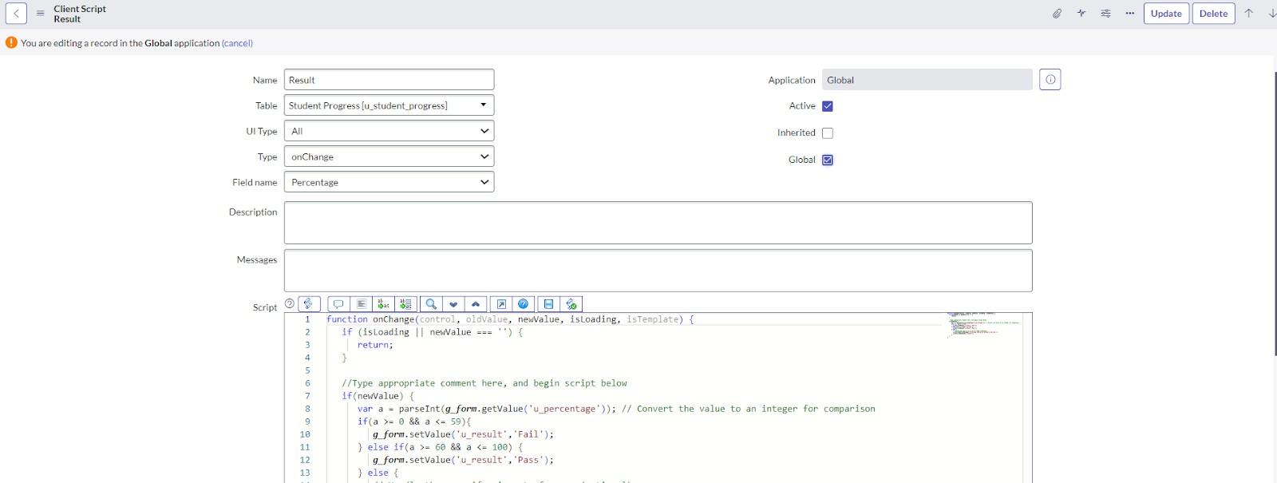

1. Write the Code as below, Enable Isolate script and Save.

function onChange(control, oldValue, newValue, isLoading, isTemplate) { if (isLoading || newValue === '') {

return;

}

//Type appropriate comment here, and begin script below if(newValue) {

var a = parseInt(g_form.getValue('u_percentage')); // Convert the value to an integer for comparison

if(a >= 0 && a <= 59){

g_form.setValue('u_result','Fail');

} else if(a >= 60 && a <= 100) { g_form.setValue('u_result','Pass');

} else {

// Handle the case if a is out of range (optional) g_form.addErrorMessage('Percentage should be between 0 and 100.'); g_form.clearValue('u_result');

}

}

}

**Activity 6: Creating “Percentage” Client Scripts For Student Progress Table**

1. Fill the Details as given.

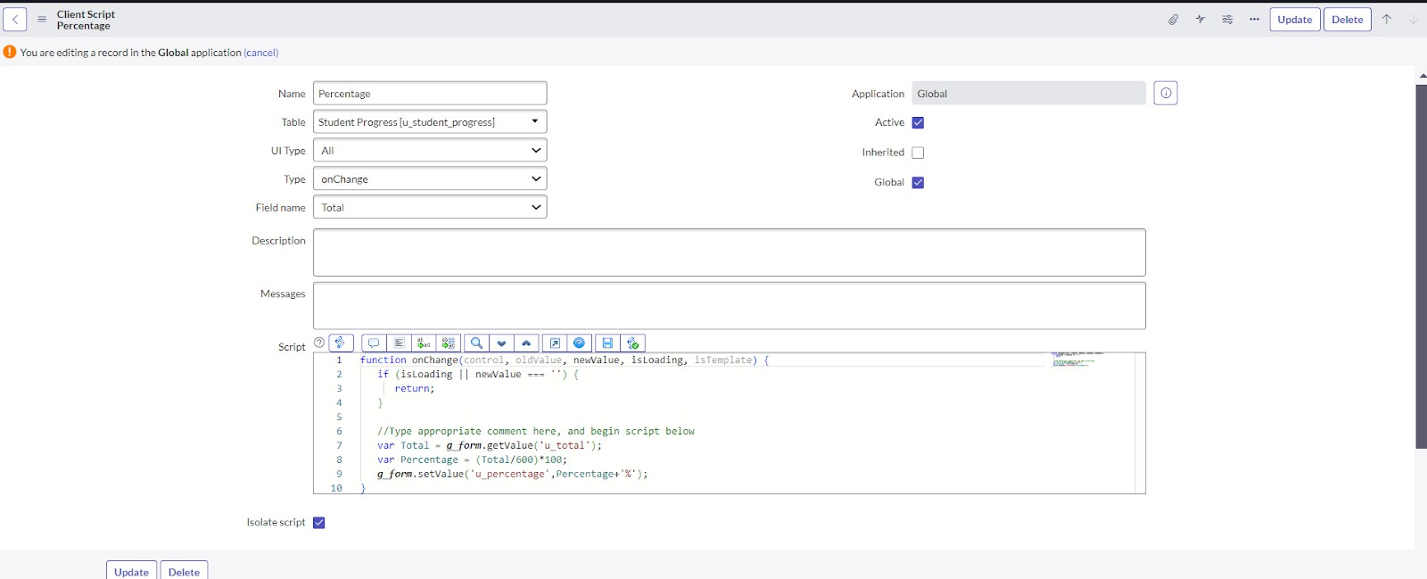

1. Write the Code as below, Enable Isolate script and Save.

function onChange(control, oldValue, newValue, isLoading, isTemplate) { if (isLoading || newValue === '') {

return;

}

//Type appropriate comment here, and begin script below var Total = g_form.getValue('u_total');

var Percentage = (Total/600)*100; g_form.setValue('u_percentage',Percentage+'%');

}

**Result**

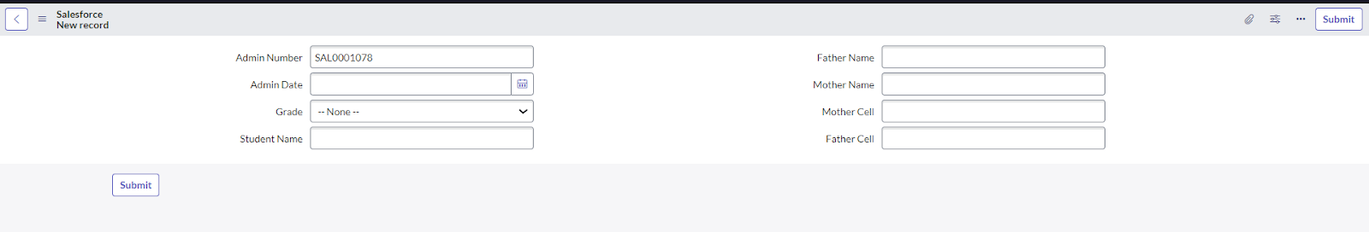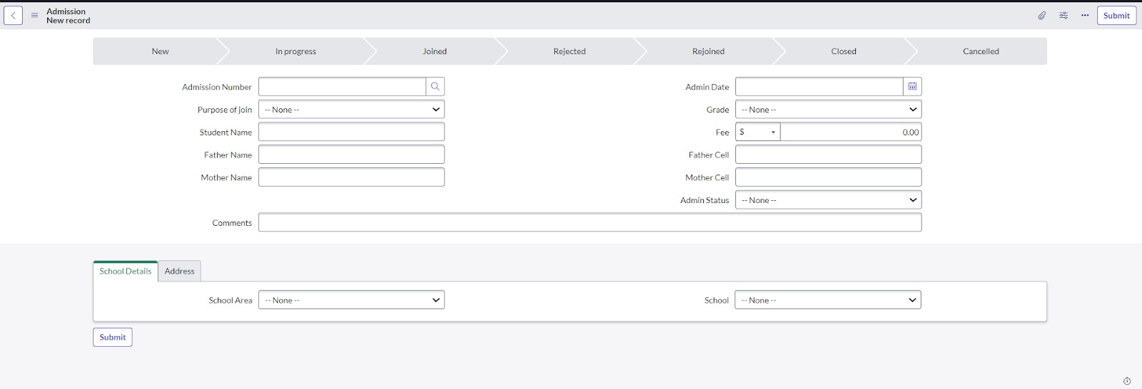

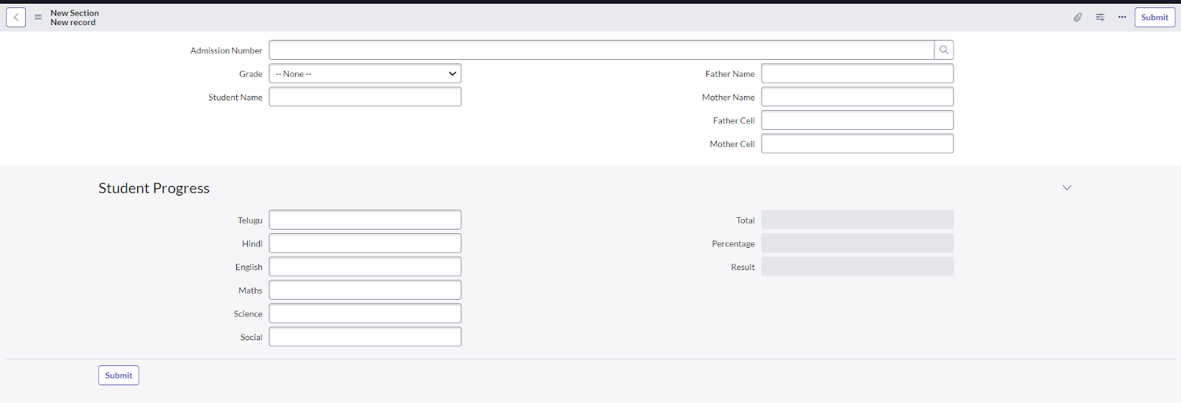

**Conclusion :**